Handheld VNIR/SWIR Field Spectroradiometer
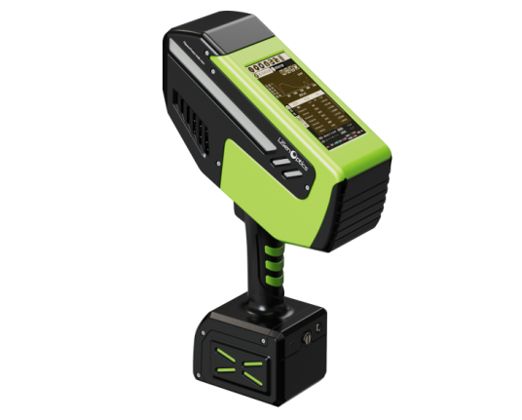
The iSpecField-(W)NIR-HH handheld field spectroradiometer from LiSen Optics integrates VNIR/SWIR spectral sensing with synchronized target imaging, offering spectral ranges from 350–1700 nm or 350–2500 nm for comprehensive field measurements. Equipped with 2048-pixel CMOS and 512-pixel InGaAs detectors, a high-stability holographic grating optical design, and an 8 MP imaging module, it delivers accurate spectral data with real-time target visualization. With IP5X protection and a fully sealed IP6X optical core, the iSpecField-(W)NIR-HH ensures reliable performance for mineral exploration, geological mapping, soil analysis, environmental monitoring, and other demanding field applications.
iSpecField-NIR-HH
Typical Applications
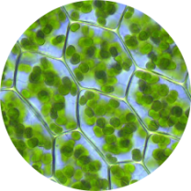
Agricultural Research

Environmental Monitoring

Marine Research

Nitrogen Measurement

Biomass Research

Key Advantages
- Broad Spectral Coverage: 350–1700 nm or 350–2500 nm range with CMOS and InGaAs detectors for high-resolution spectral measurements.
- Integrated Imaging: 8 MP camera module for synchronized field imagery and enhanced data traceability.
- Smart Acquisition: Automatic shutter control, dynamic compensation, and one-touch measurement for efficient field workflows.
- Rugged Field Design: IP5X housing and IP6X sealed optical core for reliable operation in harsh environments.
- AI Mineral Identification: AI-powered recognition of 380+ minerals with ranked matches and expandable spectral libraries.
- Advanced Spectral Analysis: SpecAnalysis software with ENVI compatibility, USGS spectral library, and 40+ vegetation indices.
- Flexible Connectivity: USB Type-C, Wi-Fi transfer, and optional 4G cloud synchronization.
- Real-Time Display: 5.5-inch industrial touchscreen for live spectra and analysis results.

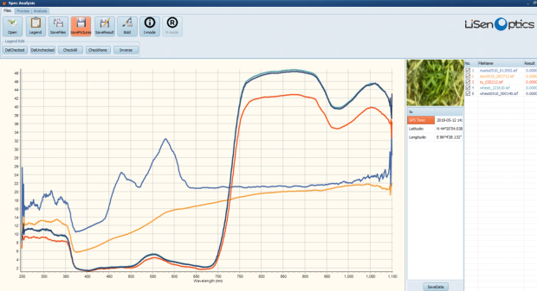
SpecAnalysis - Spectral Analysis Software

Key Specifications

Model | iSpecField-NIR-HH | iSpecField-WNIR-HH
Wavelength Range | 350-1700 nm | 350-2500 nm
Wavelength Accuracy | ≤±0.5 nm | ≤±0.5 nm
Wavelength Reproducibility | ±0.5 nm | ±0.5 nm
Spectral Resolution | ≤3 nm @ 350-1100 nm  ≤8 nm @ 1100-1700 nm | ≤3 nm @ 350-1100 nm  ≤7 nm @ 1100-2500 nm
Spectral Wavelength Sampling Interval | 1 nm @ 350-1100 nm  1 nm @ 1100-1700 nm | 1 nm @ 350-1100 nm  1 nm @ 900-1700 nm  1 nm @ 1700-2500 nm
Spectral Channels | 1350 | 2150
Noise Equivalent Radiance (NER) | 1.0 x 10^-8 W/cm²/nm/sr @ 700 nm  8.0 x 10^-8 W/cm²/nm/sr @ 1500 nm | 1.0 x 10^-8 W/cm²/nm/sr @ 700 nm  3.0 x 10^-8 W/cm²/nm/sr @ 1500 nm  6.0 x 10^-8 W/cm²/nm/sr @ 2500 nm
Detector | 2048-pixel CMOS / 256-pixel InGaAs | 2048-pixel CMOS / 512-pixel InGaAs
Minimum Integration Time | ≥6 ms |  | ≥500 ms
Battery Life | ≥3 hours (removable) |  | ≥3.5 hours (removable)
Scan Mode | Fixed holographic-grating spectrograph
Built-in Functions | GPS, 8 MP autofocus HD camera, temperature and humidity sensor
Storage | 256GB
AI Mineral Spectral Classification | Spectral matching using SAM, SFF, SID algorithms combined with LiSen Optics deep learning models. USGS spectral library included. Supports classification of 380+ mineral types. Outputs top 10 matches ranked by similarity. User-defined spectral library supported.
Acquisition Mode | PDA-style capacitive touchscreen
Touchscreen Size | 5.5-inch
Field Reflectance Probe | Built-in self-compensating optical path with internal reference spectrum. Automatic dark-current correction, white-reference calibration, and reference storage. Reduced spectral noise and wavelength drift via internal calibration system.IP67-rated sealed housing for dust and water resistance.
Data Transfer | USB Type-C; optional Wi-Fi and 4G wireless data transfer
Spectral Software | Real-time display of reflectance spectra, wavelength-specific reflectance, and integrated reflectance. Supports CIE 1976 L*a*b* color space measurements and more than 40 vegetation indices, including NDVI, DVI, EVI, CARI, PRI, RDVI, RVI, SAVI, SIPI, TVI, WI, VARI_700, and VARI_green. Compatible with iSpecField acquisition software (on-device) and SpecAnalysis post-processing software. Supports ENVI-compatible data export and includes the USGS spectral library.
Dimensions / Weight | 400 x 277 x 110 mm / 3.5 kg
Operating Temperature | -20°C to 40°C

